**Create a SPFx Webpart for SharePoint 2019**

**\*One-time activity**

**Open command prompt and execute**

**npm uninstall -g yo gulp**

**npm install gulp-cli@2.3.0 yo@3 @microsoft/generator-sharepoint@1.10.0 –global**

Develop SharePoint Framework Web Part

1. Open command prompt. Create a directory for SPFx solution.

1. md spfx-sp2019-onprem

2. Navigate to above created directory.

1. cd spfx-sp2019-onprem

3. Run Yeoman SharePoint Generator to create the solution.

1. yo @microsoft/sharepoint

4. Yeoman generator will present you with the wizard by asking questions about the solution to be created.

5. Yeoman generator will perform scaffolding process to generate the solution. The scaffolding process will take significant amount of time.

6. Once the scaffolding process is completed, lock down the version of project dependencies by running below command.

npm shrinkwrap

7.In the command prompt type below command to open the solution in code editor of your choice.

code .

It will open Visual Studio code

**gulp trust-dev-cert (one time)**

**gulp serve**

**Test the webpart in local**

**Update the code**

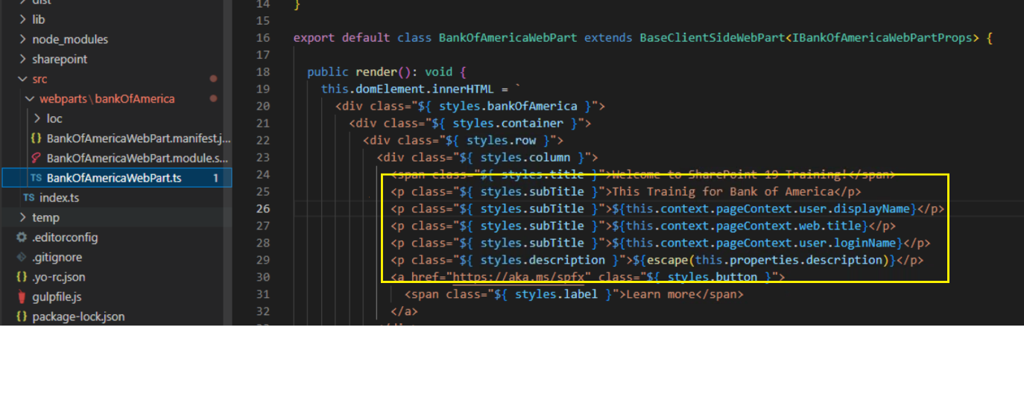

**Done**

Prepare the Package

We will now prepare a package (.sppkg) to deploy to SharePoint app catalog.

**Bundle the solution**

In the command prompt, type the below command.

1. gulp bundle --ship

This command will minify the required assets to “temp\deploy” folder.

**Package the solution**

In the command prompt, type the below command.

1. gulp package-solution --ship

This will create the solution package (sppkg) in sharepoint\solution folder.

Upload the Package to App Catalog

We will upload the SPFx package to app catalog to make it available on all sites.

1. Open SharePoint App Catalog site.

2. From left menu, click Apps for SharePoint.

3. Click Upload to add SPFx package from “\sharepoint\solution” location.

4. Click OK.

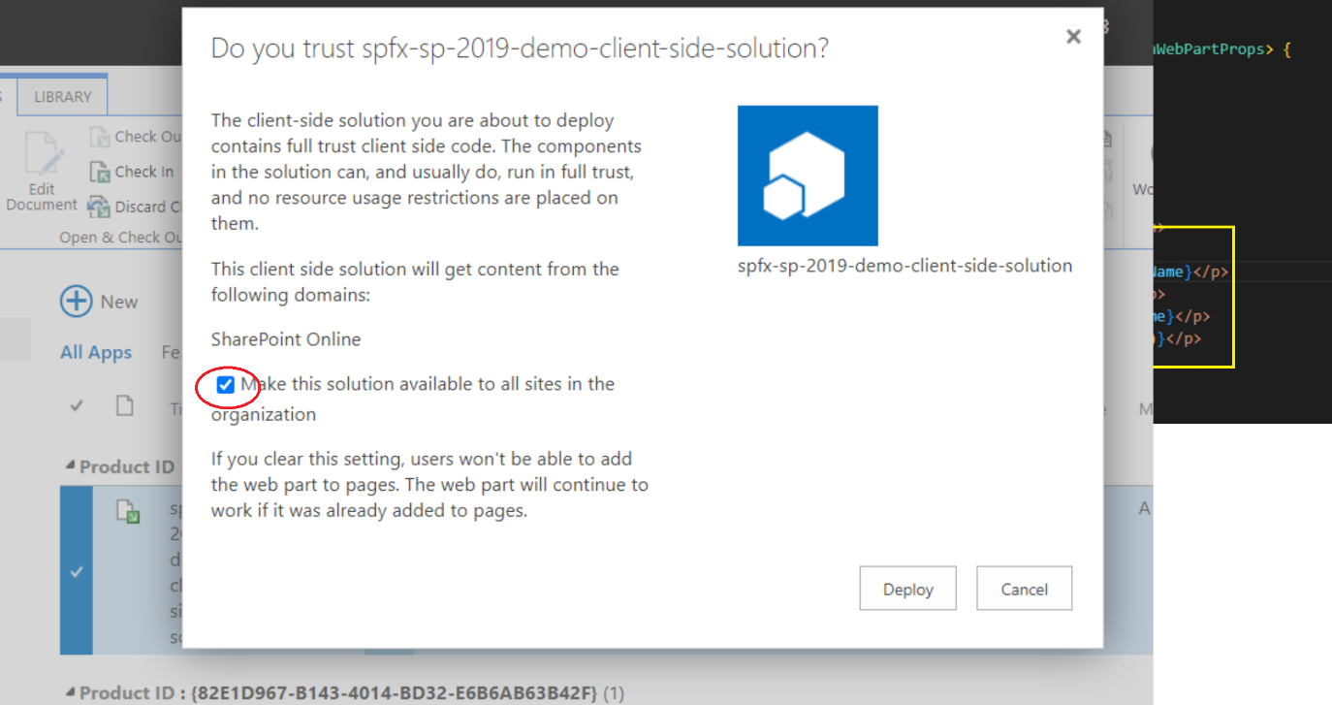

5. Click Deploy.

Add SPFx Web Part to Modern Page

Once the SPFx solution is successfully deployed to SharePoint site, we will add web part to modern page.

1. Open existing or create a new modern page.

2. On the column, click + sign to add a web part to page.

3. The web part is rendered on the page.

4. Click F12 to open the developer dashboard and observe the CDN from where the assets are being loaded from.

